Student’s Name: _____________________ Class: ________ ( ) Date: ____________

Relevant Module | Key Term / Concept Related
2 Hong Kong Today | Quality of life; economic development; social development; Individual Visit Scheme; Gross Domestic Product

 | News focus: Economic and social development in Hong Kong  (Used with Module 2 Theme 1 Topic 1 Quality of life)

Source A: A learning journey video of ‘Pharmacy Street’ in Sheung Shui

Students can visit the following website to watch the learning journey video:
https://www.youtube.com/watch?v=zXxJ6y8zLCE | 

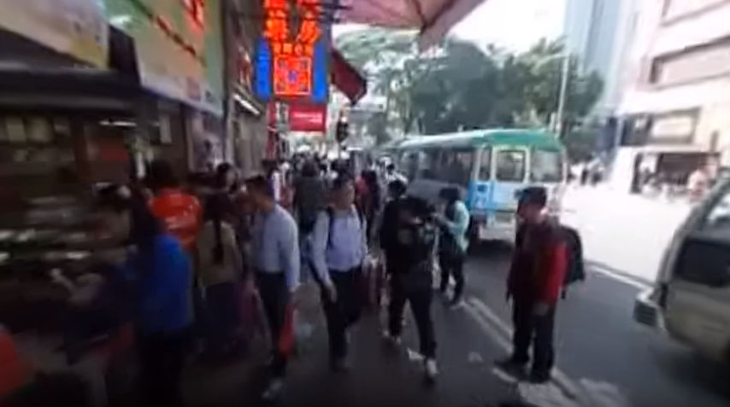

Source B: A learning journey video of Nam Shan Shopping Centre in Shek Kip Mei

Students can visit the following website to watch the learning journey video:
https://www.youtube.com/watch?v=0wg4TUE2_LQ | 

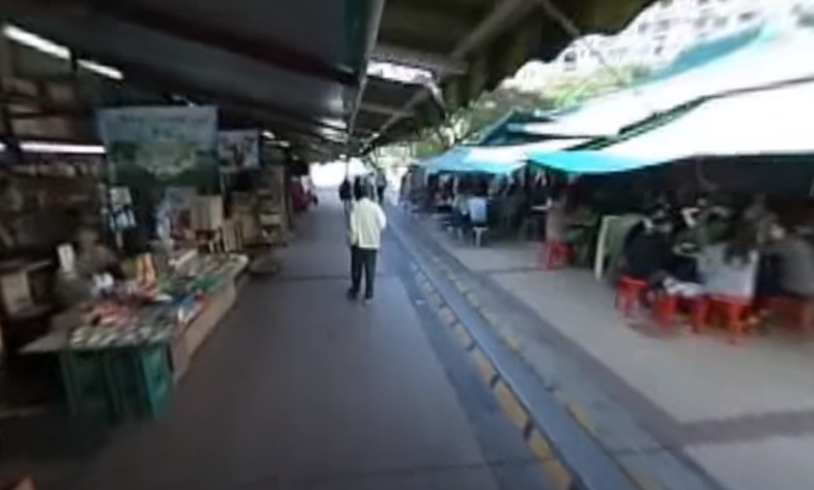

Source C: Adapted from a newspaper report dated 15 March 2016
Since the launch of the Individual Visit Scheme in 2003, the number of mainland visitors to Hong Kong has increased from 4.26 million in 2004 to 27.46 million in 2014. According to a study report issued by the Legislative Council in May 2014, the Individual Visit Scheme not only brought HKD26.1 billion of economic gains (about 1.3% of Gross Domestic Product) to Hong Kong’s economy in 2012 but also created 114 280 jobs.
Driven by the tourists of the Individual Visit Scheme, shop rents in some regions of the New Territories, such as Sheung Shui, Yuen Long and Tuen Mun, has risen considerably. According to the rateable value of property in Hong Kong announced by the Rating and Valuation Department in 2016, the rental value of ground-floor shops on San Kung Street in Sheung Shui, where numerous pharmacies can be found, surged four times in six years. Some economists pointed out that with the surging rents, small shops which mainly served local residents could not afford the high rents and were forced to close down.

 | Questions

1 (a) As shown in the learning journey video in Source A, what are the characteristics of the shops on that street in Sheung Shui?
____________________________________________________________________
____________________________________________________________________
____________________________________________________________________

(b) Why is there such a phenomenon? Explain your answer using your own knowledge.
____________________________________________________________________
____________________________________________________________________
____________________________________________________________________
____________________________________________________________________
____________________________________________________________________
____________________________________________________________________
____________________________________________________________________
____________________________________________________________________
____________________________________________________________________

2 (a) As shown in the learning journey video in Source B, what are the characteristics of the shops in Nam Shan Shopping Centre?
____________________________________________________________________
____________________________________________________________________

(b) Do you think these shops can help improve residents’ quality of life? Explain your answer.
____________________________________________________________________
____________________________________________________________________
____________________________________________________________________
____________________________________________________________________
____________________________________________________________________
____________________________________________________________________
____________________________________________________________________
____________________________________________________________________

