Student’s Name: _____________________ Class: ________ ( ) Date: ____________

Relevant Module | Key Term / Concept Related
4 Globalisation | Globalisation; cultural exchange; transportation; time-space compression; international trade

 | News focus: The relationship between transportation and globalisation  (Used with Module 4 Topic 1 Features and development of globalisation)

Source A: A learning journey video of Hong Kong International Airport

Students can visit the following website to watch the learning journey video:
https://www.youtube.com/watch?v=Mlvzl3BI6D0&feature | 

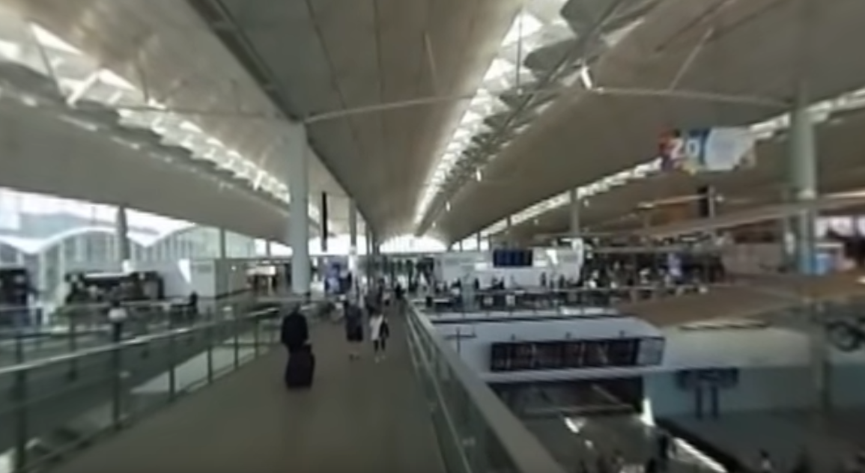
Teachers can visit our website to watch more learning journey videos and download flipped classroom worksheets:
https://www.mceducation.com.hk/vr/index.htm


Source B: An introduction to Hong Kong International Airport
Hong Kong International Airport, located in Chek Lap Kok of Lantau Island, is currently the only civil aviation airport in Hong Kong and one of the world’s busiest passenger airports. It covers an area of 1 255 hectares. There are two terminals, two runways and 182 aprons. The airport is operated by the Airport Authority of Hong Kong, which has formulated comprehensive planning of passenger and cargo traffic, business, ground support services and other facilities.

Source C: Adapted from a newspaper report dated 30 June 2017
Hong Kong International Airport (HKIA) connects with about 180 destinations in the world, with more than 100 airlines in operation there. It offers over 1 100 flights a day. Planes fly across the Middle East, Americas, Asia Pacific and other places. It has become the world’s busiest airport by cargo traffic for seven consecutive years since 2010. In 2016, the total passenger capacity reached 70.5 million and the total cargo capacity was 4.52 million tonnes. HKIA is the world’s second busiest airport in terms of international passenger traffic. It has also been rated as the World’s Best Airport for eight times over the past years.
However, HKIA will become saturated between 2018 and 2023. There is an urgent need to build the third runway in order to cope with the bottleneck of expanding passenger and cargo traffic. Some scholars said that internationalisation is the biggest advantage of Hong Kong and HKIA is essential for Hong Kong to become a global city.

 | Questions

1 (a) Which place of Hong Kong International Airport is shown in the learning journey video in Source A?
The learning journey video in Source A shows the Terminal of the Hong Kong International Airport.

____________________________________________________________________
____________________________________________________________________

(b) What infrastructure and management system does Hong Kong International Airport have? With reference to Sources A and B, explain your answer.
‧ There are two terminals which can accommodate a large number of passengers.
‧ There are two runways which allow large aircraft to go up and down.
‧ There are 182 aprons for planes to park safely.
‧ The airport is operated by the Airport Authority of Hong Kong, which has formulated comprehensive planning of facilities and services.
(Or other possible answers)

____________________________________________________________________
____________________________________________________________________
____________________________________________________________________
____________________________________________________________________
____________________________________________________________________
____________________________________________________________________
____________________________________________________________________

2 What features of globalisation does Hong Kong International Airport show? With reference to Source C, explain your answer.
‧ The airport connects with about 180 destinations in the world and offers 1 100 flights a day. This helps to break time and space constraints among countries.
‧ Planes fly across the Middle East, Americas, Asia Pacific and other places. This shows an increase in people’s mobility. People can travel between different places more quickly.
‧ The airport has become the world’s busiest airport by cargo traffic for seven consecutive years. This shows cross-border production, trade and financial activities have become more frequent,
‧ The total passenger capacity reached 70.5 million, which makes it the world’s second busiest airport. People in different places have more opportunities to interact with each other.
(Or other possible answers)

_______________________________________________________________________
_______________________________________________________________________
_______________________________________________________________________
_______________________________________________________________________
_______________________________________________________________________
_______________________________________________________________________
_______________________________________________________________________
_______________________________________________________________________
_______________________________________________________________________

