Student’s Name: _____________________ Class: ________ ( ) Date: ____________

Relevant Module | Key Term / Concept Related
2 Hong Kong Today | Credibility; legitimacy; sense of belonging; civic awareness; sense of identity; electoral system; political efficacy; socio-political participation

 | News focus: Participation of Hong Kong residents in social and political affairs  (Used with Module 2 Topic 3 Rule of law and socio-political participation)

Source A: A learning journey video of July 1 march

Students can visit the following website to watch the learning journey video:
https://www.youtube.com/watch?v=KL88VkmyRAM&feature | 

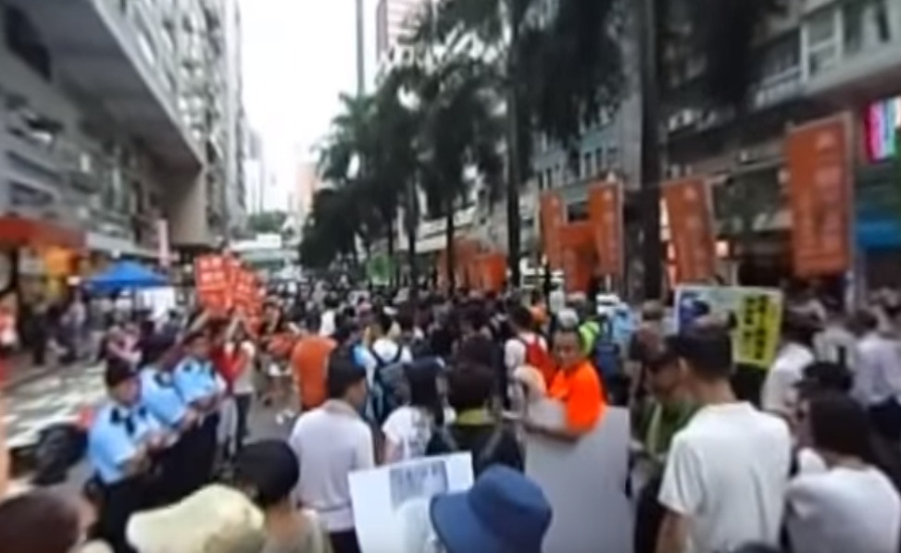

Source B: An introduction to July 1 march
The July 1 march is a large march launched by social movement organisations such as the Civil Human Rights Front. It has been held on 1 July every year since Hong Kong’s Handover in 1997. It did not draw much public attention until 2003 because the government intended to implement the legislation of the controversial Article 23 of the Basic Law, which caused widespread concern that Hong Kong people’s freedom and human rights would be affected. In addition, government officials did not handle the SARS outbreak properly and this brought public outrage during that year. As a result, a large number of people took to the street to express their discontent with the government. Some organisations estimated more than 500 000 people joined the protest.

Source C: An excerpt from an article dated 23 July 2017
Every year the July 1 march calls for the Chief Executive to step down, but the reasons behind it are not the same. During the Tung Chee-hwa period, the public criticised the Chief Executive for his poor governance. People refused to support Tung because they hoped that a new leader could lead Hong Kong out of the economic downturn. During the Leung Chun-ying period, in addition to a demand for the Chief Executive’s quality of governance, the public even demanded more of his personal integrity and credibility. The root of the problem lay in the fact that there was no broadly representative electoral system. The reason for ‘Anti-Leung’, apart from his personal virtues, was that the public was dissatisfied with the political system in which the Chief Executive was elected. The purpose of the march was to call for improvements in people’s livelihood arising from political problems by reforming the system.
Five or six years after the Handover, due to economic recession, people usually marched to criticise government officials for failing to understand the needs of people from all social strata and to solve social conflicts. Later, the discontent of the public was directed against collusion between the government and the business sector and developer hegemony. In recent years, economic and livelihood issues have drawn less attention and so the focuses of the marches shifted to more controversial topics, such as fighting for universal suffrage and political reform. Some organisations have even put forward the slogan of safeguarding Hong Kong’s high degree of autonomy.

 | Questions

1 (a) Describe the July 1 march shown in the learning journey video in Source A.
____________________________________________________________________
____________________________________________________________________
____________________________________________________________________
____________________________________________________________________

(b) According to Source B, in which year did the July 1 march begin to draw public attention? Why? Explain your answer.
____________________________________________________________________
____________________________________________________________________
____________________________________________________________________
____________________________________________________________________
____________________________________________________________________
____________________________________________________________________
____________________________________________________________________
____________________________________________________________________
____________________________________________________________________

2 How did the July 1 march change over the years? With reference to Source C, explain your answer.
_______________________________________________________________________
_______________________________________________________________________
_______________________________________________________________________
_______________________________________________________________________
_______________________________________________________________________
_______________________________________________________________________
_______________________________________________________________________
_______________________________________________________________________
_______________________________________________________________________
_______________________________________________________________________
_______________________________________________________________________
_______________________________________________________________________
_______________________________________________________________________
_______________________________________________________________________
_______________________________________________________________________
_______________________________________________________________________
_______________________________________________________________________
_______________________________________________________________________
_______________________________________________________________________
_______________________________________________________________________

