Student’s Name: _____________________ Class: ________ ( ) Date: ____________

Relevant Module | Key Term / Concept Related
3 Modern China | Collective memory; traditional custom; dragon boat race; cultural cohesion

 | News focus: The significance of traditional customs in the modern society  (Used with Module 3 Topic 5 Chinese culture and modern life)

Source A: A learning journey video of the dragon boat race in Shatin

Students can visit the following website to watch the learning journey video:
https://www.youtube.com/watch?v=YQAE6eNUUT8&feature | 

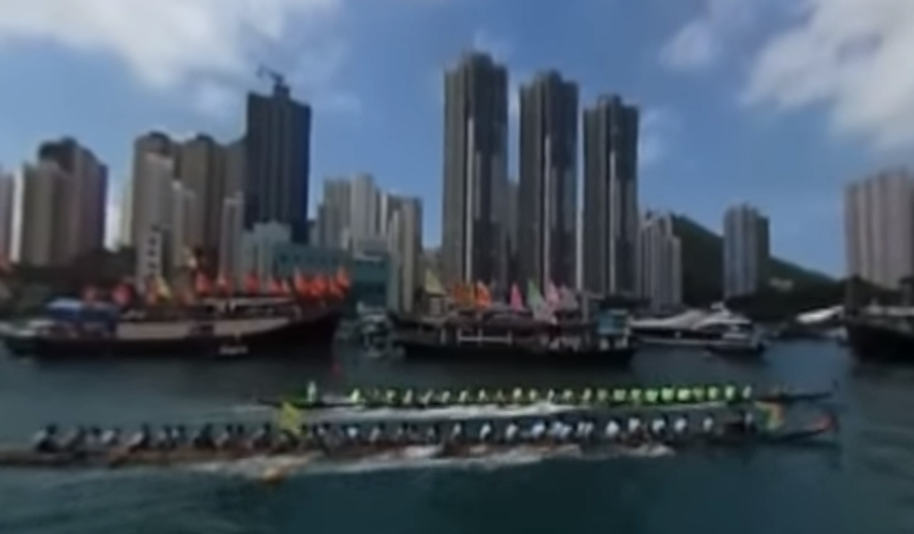
Teachers can visit our website to watch more learning journey videos and download flipped classroom worksheets:
https://www.mceducation.com.hk/vr/index.htm


Source B: An introduction to Hong Kong International Dragon Boat Races
The Hong Kong International Dragon Boat Races is an international event in Hong Kong. It was first held in 1976 and hosted by Hong Kong Tourist Association, which helped promote dragon boat races to all parts of the world. In 2007, the Hong Kong International Dragon Boat Races was included in one of the 10th anniversary events celebrating the establishment of the Hong Kong Special Administrative Region. In June 2017, it was held at Central Harbourfront for three consecutive days. More than 160 teams from all over the world took part in the race. Around 5 000 athletes competed with one another by rowing their boats, showing the influence of the event on the world.

Source C: Adapted from a newspaper report dated 15 August 2016
The rapid development of modern society and the ever-changing lifestyle not only cause some customs to be eliminated, but also make new changes in the remaining customs. For example, burial is the main practice of traditional funerals. However, owing to the growing population, lack of land supply and increasing environmental awareness, burial is gradually replaced by cremation. In the modern society, some traditional festivals become a good chance for people to have parties and go shopping. Traditional customs are therefore materialised and even distorted into commercial activities. In spite of this, some traditional customs have gradually been forgotten in society due to lack of business opportunities, such as hiking in Chung Yeung Festival. With the influence of globalisation, more and more Chinese people accept Western cultural trends and celebrate Western festivals, such as Christmas and Halloween. Nevertheless, the rituals and etiquette of traditional customs are too conservative and old-fashioned for young people.

 | Questions

1 (a) What characteristics of traditional customs are reflected in the dragon boat race as shown in the learning journey video in Source A? Name two and explain.
‧ Collective: Dragon boat races are the behaviour patterns practised by members of an ethnic group or people from a particular region, instead of by individual member or family.
‧ Region-specific: There are a lot of rivers in Hong Kong which are suitable for dragon boat races. The natural resources and geographical features form specific customs.
‧ Can be passed down: Dragon boat races are the custom of Dragon Boat Festival to commemorate Qu Yuan. The younger generation pass down the culture of an ethnic group.
(Or other possible answers)
____________________________________________________________________
____________________________________________________________________
____________________________________________________________________
____________________________________________________________________
____________________________________________________________________
____________________________________________________________________
____________________________________________________________________
____________________________________________________________________

(b) According to Source B, what is the importance of the Hong Kong International Dragon Boat Races to Hong Kong?
‧ The Hong Kong International Dragon Boat Races has certain historical significance. It was first held in 1976 and has a history of more than 40 years. In 2007, it was included in one of the 10th anniversary events celebrating the establishment of the Hong Kong Special Administrative Region.
‧ The Hong Kong International Dragon Boat Races is one of the most representative international events in Hong Kong. In 2017, more than 160 teams from all over the world took part in the race, which shows that this event has certain international influence.
(Or other possible answers)
____________________________________________________________________
____________________________________________________________________
____________________________________________________________________
____________________________________________________________________
____________________________________________________________________
____________________________________________________________________
____________________________________________________________________
____________________________________________________________________
____________________________________________________________________

2 What are the factors affecting the continuity of traditional customs? With reference to Source C and your own knowledge, explain your answer.
‧ Social change: The rapid development of modern society and the ever-changing lifestyle cause some customs to be eliminated or have new changes. As mentioned in Source C, burial is the main practice of traditional funerals. However, owing to the growing population, lack of land supply and increasing environmental awareness, burial is gradually replaced by cremation.
‧ Commercial values: Some traditional customs are connected with business and become a good chance for people to have parties and go shopping, so they can continue and develop. In spite of this, some traditional customs have gradually been forgotten in society due to lack of business opportunities, such as hiking in Chung Yeung Festival.
‧ Challenges from foreign cultures: Under the influence of globalisation, Western culture has gradually been globally accepted. As mentioned in Source C, more and more Chinese people accept Western cultural trends and celebrate Western festivals, such as Christmas and Halloween. Nevertheless, the rituals and etiquette of traditional customs are too conservative and old-fashioned for young people.
(Or other possible answers)

_______________________________________________________________________
_______________________________________________________________________
_______________________________________________________________________
_______________________________________________________________________
_______________________________________________________________________
_______________________________________________________________________
_______________________________________________________________________
_______________________________________________________________________
_______________________________________________________________________
_______________________________________________________________________
_______________________________________________________________________
_______________________________________________________________________
_______________________________________________________________________
_______________________________________________________________________
_______________________________________________________________________
_______________________________________________________________________

