Student’s Name: _____________________ Class: ________ ( ) Date: ____________

Relevant Module | Key Term / Concept Related
6 Energy Technology and the Environment | Energy; wind power; coal-fired; solar energy; renewable energy; non-renewable energy

 | News focus: Use of energy to generate electricity in Hong Kong  (Used with Module 6 Theme 1 Topic 3 The development of renewable energy)

Source A: A learning journey video of Lamma Winds and Lamma Power Station

Students can visit the following website to watch the learning journey video:
https://www.youtube.com/watch?v=Xx_WBc_G5Ao&feature=youtu.be | 
Lamma Winds
Lamma Power Station
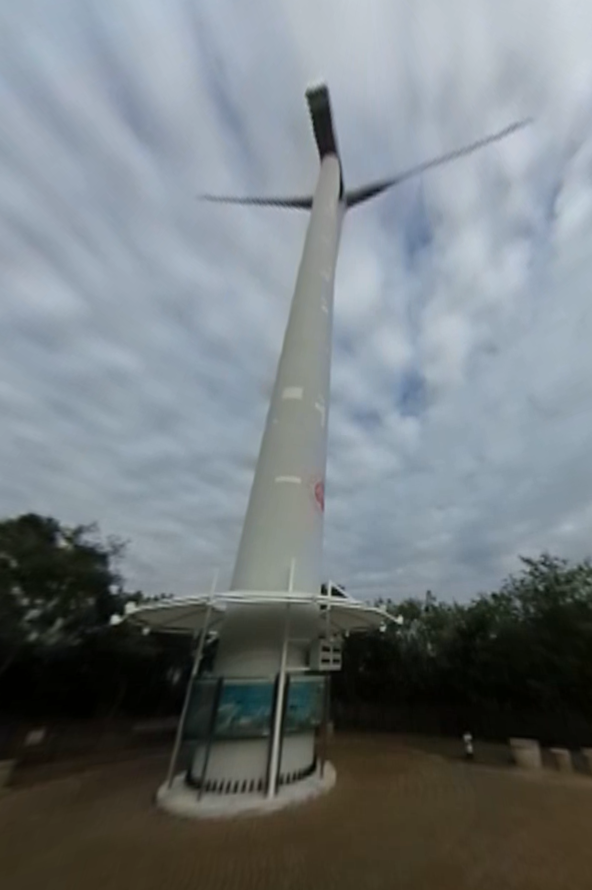 | 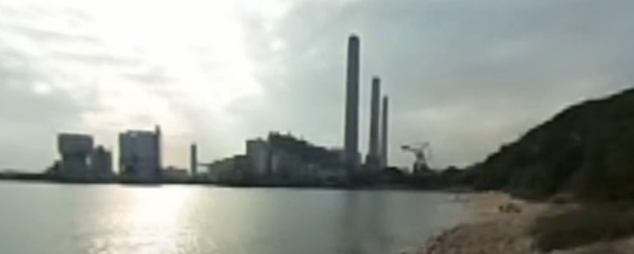  Teachers can visit our website to watch more learning journey videos and download flipped classroom worksheets:  https://www.mceducation.com.hk/vr/index.htm  

Source B: An introduction to Lamma Winds
Lamma Winds is located at Tai Ling on Lamma Island. It is the first wind power station for commercial use in Hong Kong. It cost the Hongkong Electric Company HKD15 million to build and was officially opened on 23 February 2006. It is expected to generate nearly 1 million units of electricity annually, enough for 250 households to use for one year.

Source C: Adapted from a newspaper report dated 1 May 2016
What causes Hong Kong’s development of wind power to fall behind its regional neighbours? A senior engineer at the Electrical and Mechanical Services Department pointed out that the biggest obstacle is lack of land. He said, ‘A wind farm takes up a lot of space. A wind farm that generates 1% of local electricity consumption requires about 20 square kilometres of land or sea, which is equivalent to one-fourth of the area of Hong Kong Island.
Regarding solar energy, although the two electric companies installed solar power systems on Lamma Island and Dawn Island respectively, the electricity production only accounts for 0.01% of the whole. The government has promoted the development of solar energy, but the measures are limited to the installation of solar power generation devices in government buildings and public facilities. On the other hand, Macau, which has less land than Hong Kong, introduced a policy in 2015 that encouraged owners of residential and commercial buildings to install solar power generation facilities. The electricity generated is provided for their own use and the remaining electricity can be delivered to Companhia de Electricidade de Macau (CEM). CEM will pay for buyback fees and allocate the electricity to other residents.

 | Questions

1 (a) The learning journey video in Source A shows two types of power generation facilities using different energy sources. Identify and explain your answer.
‧ Firstly, Source A shows Lamma Winds which uses wind power to generate electricity.
‧ Secondly, Source A shows Lamma Power Station which uses coal and natural gas to generate electricity.

____________________________________________________________________
____________________________________________________________________
____________________________________________________________________
____________________________________________________________________

(b) What are the characteristics of these two power generation facilities? Give ONE for each and explain.
‧ Lamma Winds: It is located in the highland, with no barriers on all sides.
‧ Lamma Power Station: It is located near the sea, with three sides surrounded by the sea.
(Or other possible answers)

____________________________________________________________________
____________________________________________________________________
____________________________________________________________________
____________________________________________________________________

(c) Which power generation facility do you think is better? Why?
‧ Free answers.
‧ I think Lamma Winds is better because wind power is a renewable energy source which never runs out. No pollutants are produced in the process of electricity generation, which causes less damage to the environment. /
‧ I think Lamma Power Station is better because the generation efficiency of coal-fired power is higher and the power supply is more stable. Besides, using natural gas to generate electricity releases fewer greenhouse gases and air pollutants, which causes less harm to global warming.
(Or other possible answers)

____________________________________________________________________
____________________________________________________________________
____________________________________________________________________
____________________________________________________________________
____________________________________________________________________
____________________________________________________________________
____________________________________________________________________
____________________________________________________________________
____________________________________________________________________

2 What do you think are the possible obstacles to Hong Kong’s development of renewable energy? With reference to Source C and your own knowledge, explain your answer.
‧ Firstly, lack of land in Hong Kong causes its development of wind power to fall behind its regional neighbours. A wind farm takes up a lot of space. For example, a wind farm that generates 1% of local electricity consumption requires about 20 square kilometres of land or sea, which is equivalent to one-fourth of the area of Hong Kong Island. However, the land resource in Hong Kong now is already very limited. It is even difficult to get land for building houses, not to mention opening up such a large area of land for installing wind power facilities.
‧ Besides, lack of government promotion makes the development of solar energy still immature. Compared to the policy introduced by Macau in 2015, which encouraged owners of buildings to install solar power generation facilities and earn buyback fees, the measures taken by the Hong Kong government are only limited to the installation of solar power generation devices in government buildings and public facilities. The lack of policies to encourage the use of solar energy among residents causes the development of solar energy in Hong Kong to remain stagnant.
(Or other possible answers)

_______________________________________________________________________
_______________________________________________________________________
_______________________________________________________________________
_______________________________________________________________________
_______________________________________________________________________
_______________________________________________________________________
_______________________________________________________________________
_______________________________________________________________________
_______________________________________________________________________
_______________________________________________________________________
_______________________________________________________________________
_______________________________________________________________________
_______________________________________________________________________
_______________________________________________________________________
_______________________________________________________________________

