Student’s Name: _____________________ Class: ________ ( ) Date: ____________

Relevant Module | Key Term / Concept Related
2 Hong Kong Today | Quality of life; economic development; social development; Individual Visit Scheme; Gross Domestic Product

 | News focus: Economic and social development in Hong Kong  (Used with Module 2 Theme 1 Topic 1 Quality of life)

Source A: A learning journey video of ‘Pharmacy Street’ in Sheung Shui

Students can visit the following website to watch the learning journey video:
https://www.youtube.com/watch?v=zXxJ6y8zLCE | 

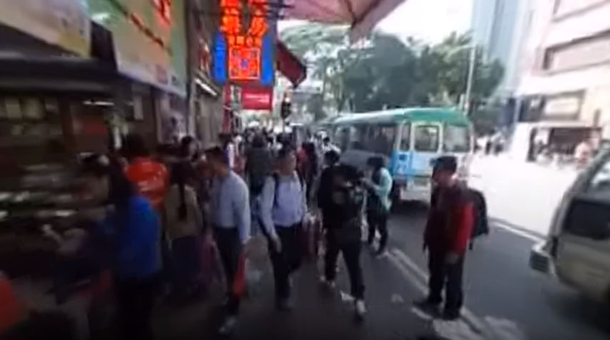
Teachers can visit our website to watch more learning journey videos and download flipped classroom worksheets:
https://www.mceducation.com.hk/vr/index.htm


Source B: A learning journey video of Nam Shan Shopping Centre in Shek Kip Mei

Students can visit the following website to watch the learning journey video:
https://www.youtube.com/watch?v=0wg4TUE2_LQ | 

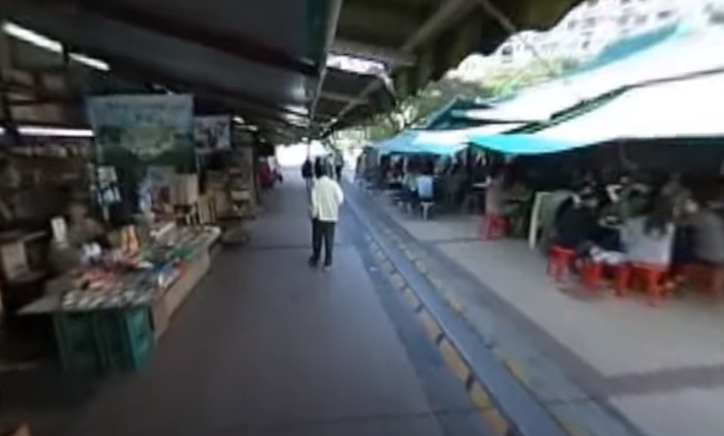

Source C: Adapted from a newspaper report dated 15 March 2016
Since the launch of the Individual Visit Scheme in 2003, the number of mainland visitors to Hong Kong has increased from 4.26 million in 2004 to 27.46 million in 2014. According to a study report issued by the Legislative Council in May 2014, the Individual Visit Scheme not only brought HKD26.1 billion of economic gains (about 1.3% of Gross Domestic Product) to Hong Kong’s economy in 2012 but also created 114 280 jobs.
Driven by the tourists of the Individual Visit Scheme, shop rents in some regions of the New Territories, such as Sheung Shui, Yuen Long and Tuen Mun, has risen considerably. According to the rateable value of property in Hong Kong announced by the Rating and Valuation Department in 2016, the rental value of ground-floor shops on San Kung Street in Sheung Shui, where numerous pharmacies can be found, surged four times in six years. Some economists pointed out that with the surging rents, small shops which mainly served local residents could not afford the high rents and were forced to close down.

 | Questions

1 (a) As shown in the learning journey video in Source A, what are the characteristics of the shops on that street in Sheung Shui?
On that street in Sheung Shui, there are mainly Chinese and Western pharmacies. RMB exchange shops can also be found.

____________________________________________________________________
____________________________________________________________________
____________________________________________________________________

(b) Why is there such a phenomenon? Explain your answer using your own knowledge.
Since the launch of the Individual Visit Scheme in 2003, more and more mainland visitors came to Hong Kong for shopping. They mainly bought daily necessities. Sheung Shui, near Luohu Port of Shenzhen, has become a shopping hot spot for many mainlanders. In view of this market demand, shops in Sheung Shui have gradually transformed into pharmacies and RMB exchange shops, which mainly serve mainlanders.
(Or other possible answers)

____________________________________________________________________
____________________________________________________________________
____________________________________________________________________
____________________________________________________________________
____________________________________________________________________
____________________________________________________________________
____________________________________________________________________
____________________________________________________________________
____________________________________________________________________

2 (a) As shown in the learning journey video in Source B, what are the characteristics of the shops in Nam Shan Shopping Centre?
There are mainly local small shops in Nam Shan Shopping Centre.

____________________________________________________________________
____________________________________________________________________

(b) Do you think these shops can help improve residents’ quality of life? Explain your answer.
‧ Free answers
‧ Yes, I think these shops can help improve residents’ quality of life because the customers are mainly residents and the goods sold are what they need. /
‧ No, I do not think these shops can help improve residents’ quality of life because they provide fewer kinds of goods and residents may not get what they need.
(Or other possible answers)

____________________________________________________________________
____________________________________________________________________
____________________________________________________________________
____________________________________________________________________
____________________________________________________________________
____________________________________________________________________
____________________________________________________________________
____________________________________________________________________

3 What are the pros and cons of the integration of Hong Kong and the mainland for Hong Kong? With reference to Source C and your own knowledge, explain your answer.
‧ Pros: The integration of Hong Kong and the mainland helps boost Hong Kong’s economic growth. For example, since the launch of the Individual Visit Scheme in 2003, the number of mainland visitors to Hong Kong has increased from 4.26 million in 2004 to 27.46 million in 2014, which rose by six times. Besides, the Individual Visit Scheme not only brought HKD26.1 billion of economic gains (about 1.3% of Gross Domestic Product) to Hong Kong’s economy in 2012 but also created 114 280 jobs. It can be seen that the integration of Hong Kong and the mainland is conducive to Hong Kong’s economic growth.
‧ Cons: The integration of Hong Kong and the mainland makes the types of retail shops become similar. For example, driven by the tourists of the Individual Visit Scheme, shop rents in some regions of the New Territories near the border of Shenzhen, such as Sheung Shui, Yuen Long and Tuen Mun, has risen considerably. On San Kung Street in Sheung Shui, where numerous pharmacies can be found, the rental value of ground-floor shops surged four times in six years. As a result, small shops which mainly served local residents could not afford the high rents and were forced to close down. This leads to the limited choices of retail shops available in the regions.
(Or other possible answers)

_______________________________________________________________________
_______________________________________________________________________
_______________________________________________________________________
_______________________________________________________________________
_______________________________________________________________________
_______________________________________________________________________
_______________________________________________________________________
_______________________________________________________________________
_______________________________________________________________________
_______________________________________________________________________
_______________________________________________________________________
_______________________________________________________________________
_______________________________________________________________________
_______________________________________________________________________
_______________________________________________________________________
_______________________________________________________________________
_______________________________________________________________________

