Student’s Name: _____________________ Class: ________ ( ) Date: ____________

Relevant Module | Key Term / Concept Related
3 Modern China | Purchasing power; standard of living; reform and opening-up; quality of Chinese citizens; international etiquette; uncivilised behaviour

 | News focus: The quality of Chinese citizens after reform and opening-up  (Used with Module 3 Theme 1 Topic 2 Impacts of the reform and opening-up on people’s life)

Source A: A learning journey video of Golden Bauhinia Square

Students can visit the following website to watch the learning journey video:
https://www.youtube.com/watch?v=GieKfhmGDuE&feature | 

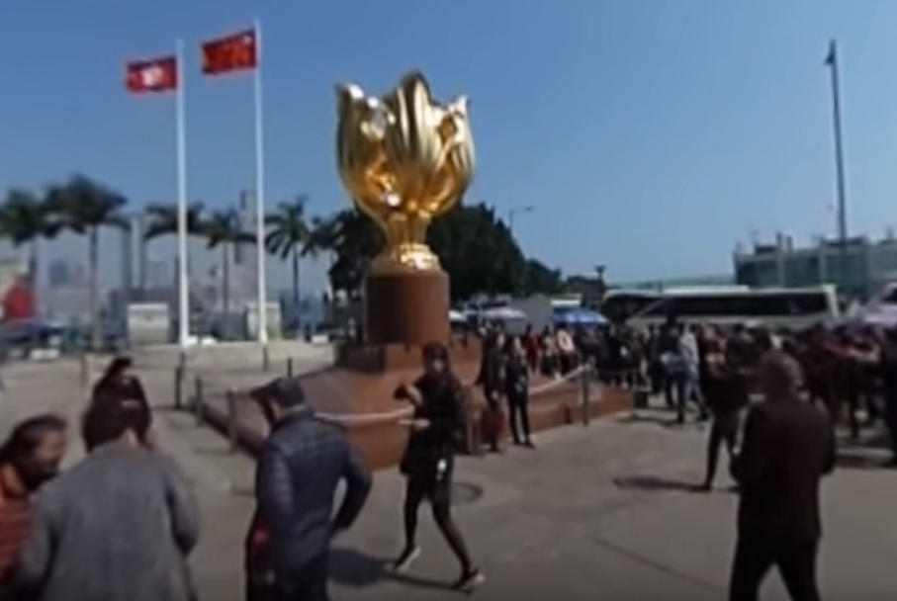

Source B: An introduction to Golden Bauhinia Square
The Golden Bauhinia Square is situated outside the Hong Kong Convention and Exhibition Centre in Wan Chai. The Forever Blooming Bauhinia Sculpture stands in the square and signifies that Hong Kong is always thriving. It was a gift from the Central Government to the Hong Kong Government to mark the 1997 Handover of Hong Kong to China. The site has become one of Hong Kong’s tourist spots that attracts a lot of mainland visitors in recent years due to its historical significance.

Source C: Adapted from a newspaper report dated 21 September 2017
Over the past decade, Chinese people have been travelling abroad frequently and other countries have taken measures to attract Chinese tourists, such as shortening the time taken for visa application. In 2003, the number of Chinese outbound tourists exceeded 20 million. China overtook Japan for the first time and became the largest tourist source in Asia. In 2011, despite the global economic downturn and the lack of momentum in the international tourism market, the number of tourists from China still reached 70.25 million, ranking second in the world. Tourists from China spent nearly USD 73 billion abroad, ranking third in the world only after the US and Germany. The World Tourism Organization predicts that by 2020, the number of Chinese outbound tourists will increase to 100 million.
However, the overseas media have repeatedly reported on the uncivilised behaviour of Chinese people when they travel abroad, for example:
- Throw rubbish, spit everywhere and do not flush the toilet after using it;
- Ignore ‘No Smoking’ signs and pollute public space;
- Scramble for the seats when taking public transport and jump the queue when waiting for a visit;
- Play around in religious places like churches and temples and do not obey the rules;
- Talk loudly in public places and behave rudely.
Some critics said that Chinese tourists must learn international etiquette and follow the usual practices when getting along with other people. The mainland tourism departments should raise public awareness of the pollution and destruction caused by uncivilised behaviour to the environment of other countries through media and the Internet.

 | Questions

1 (a) What can you see in the Golden Bauhinia Square from the learning journey video in Source A?
____________________________________________________________________
____________________________________________________________________

(b) According to Source B, what is the significance of the Golden Bauhinia Square to Hong Kong?
____________________________________________________________________
____________________________________________________________________
____________________________________________________________________
____________________________________________________________________
____________________________________________________________________
____________________________________________________________________
____________________________________________________________________
____________________________________________________________________

2 What has people’s life changed after the reform and opening-up? With reference to Source C and your own knowledge, explain your answer.
_______________________________________________________________________
_______________________________________________________________________
_______________________________________________________________________
_______________________________________________________________________
_______________________________________________________________________
_______________________________________________________________________
_______________________________________________________________________
_______________________________________________________________________
_______________________________________________________________________
_______________________________________________________________________
_______________________________________________________________________
_______________________________________________________________________
_______________________________________________________________________
_______________________________________________________________________
_______________________________________________________________________
_______________________________________________________________________

3 How does Source C reflect the quality of Chinese people? Explain your answer.
_______________________________________________________________________
_______________________________________________________________________
_______________________________________________________________________
_______________________________________________________________________
_______________________________________________________________________
_______________________________________________________________________
_______________________________________________________________________
_______________________________________________________________________
_______________________________________________________________________
_______________________________________________________________________
_______________________________________________________________________
_______________________________________________________________________
_______________________________________________________________________
_______________________________________________________________________
_______________________________________________________________________
_______________________________________________________________________
_______________________________________________________________________

