Student’s Name: _____________________ Class: ________ ( ) Date: ____________

Relevant Module | Key Term / Concept Related
3 Modern China | Purchasing power; standard of living; reform and opening-up; quality of Chinese citizens; international etiquette; uncivilised behaviour

 | News focus: The quality of Chinese citizens after reform and opening-up  (Used with Module 3 Theme 1 Topic 2 Impacts of the reform and opening-up on people’s life)

Source A: A learning journey video of Golden Bauhinia Square

Students can visit the following website to watch the learning journey video:
https://www.youtube.com/watch?v=GieKfhmGDuE&feature | 

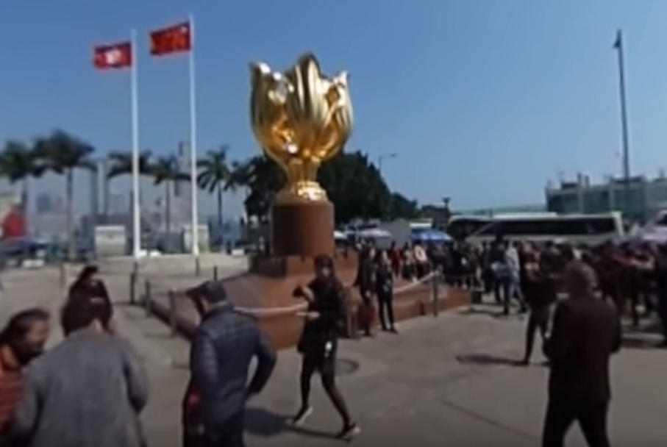
Teachers can visit our website to watch more learning journey videos and download flipped classroom worksheets:
https://www.mceducation.com.hk/vr/index.htm


Source B: An introduction to Golden Bauhinia Square
The Golden Bauhinia Square is situated outside the Hong Kong Convention and Exhibition Centre in Wan Chai. The Forever Blooming Bauhinia Sculpture stands in the square and signifies that Hong Kong is always thriving. It was a gift from the Central Government to the Hong Kong Government to mark the 1997 Handover of Hong Kong to China. The site has become one of Hong Kong’s tourist spots that attracts a lot of mainland visitors in recent years due to its historical significance.

Source C: Adapted from a newspaper report dated 21 September 2017
Over the past decade, Chinese people have been travelling abroad frequently and other countries have taken measures to attract Chinese tourists, such as shortening the time taken for visa application. In 2003, the number of Chinese outbound tourists exceeded 20 million. China overtook Japan for the first time and became the largest tourist source in Asia. In 2011, despite the global economic downturn and the lack of momentum in the international tourism market, the number of tourists from China still reached 70.25 million, ranking second in the world. Tourists from China spent nearly USD 73 billion abroad, ranking third in the world only after the US and Germany. The World Tourism Organization predicts that by 2020, the number of Chinese outbound tourists will increase to 100 million.
However, the overseas media have repeatedly reported on the uncivilised behaviour of Chinese people when they travel abroad, for example:
- Throw rubbish, spit everywhere and do not flush the toilet after using it;
- Ignore ‘No Smoking’ signs and pollute public space;
- Scramble for the seats when taking public transport and jump the queue when waiting for a visit;
- Play around in religious places like churches and temples and do not obey the rules;
- Talk loudly in public places and behave rudely.
Some critics said that Chinese tourists must learn international etiquette and follow the usual practices when getting along with other people. The mainland tourism departments should raise public awareness of the pollution and destruction caused by uncivilised behaviour to the environment of other countries through media and the Internet.

 | Questions

1 (a) What can you see in the Golden Bauhinia Square from the learning journey video in Source A?
The Forever Blooming Bauhinia Sculpture stands in the Golden Bauhinia Square, with China’s national flag and Hong Kong’s regional flag hanging high next to it.

____________________________________________________________________
____________________________________________________________________

(b) According to Source B, what is the significance of the Golden Bauhinia Square to Hong Kong?
‧ The Forever Blooming Bauhinia Sculpture stands in the square and signifies that Hong Kong is always thriving.
‧ The sculpture was a gift from the Central Government to the Hong Kong Government to mark the 1997 Handover of Hong Kong to China.
‧ The site has become one of Hong Kong’s tourist spots that attracts a lot of mainland visitors in recent years, thus promoting Hong Kong’s tourism.

____________________________________________________________________
____________________________________________________________________
____________________________________________________________________
____________________________________________________________________
____________________________________________________________________
____________________________________________________________________
____________________________________________________________________
____________________________________________________________________

2 What has people’s life changed after the reform and opening-up? With reference to Source C and your own knowledge, explain your answer.
‧ The reform and opening-up has sped up China’s economic development. People’s income and consumption ability have risen. Their purchasing power and standard of living have also substantially increased. As mentioned in Source C, Chinese people have been travelling abroad frequently. In 2003, the number of Chinese outbound tourists exceeded 20 million and China has become the largest tourist source in Asia. In 2011, despite the global economic downturn, the number of tourists from China still reached 70.25 million, ranking second in the world. Tourists from China spent nearly USD 73 billion abroad, ranking third in the world only after the US and Germany.
‧ With the development of economy, China has devoted more resources towards education. Basic education has gradually become accessible. More and more people receive higher education. People’s education levels have continuously improved.
‧ The life expectancy of the population in China is above the world’s average. The infant mortality rate has continuously decreased. The standard of medical and healthcare services has improved significantly. People’s health is better protected.
(Or other possible answers)

_______________________________________________________________________
_______________________________________________________________________
_______________________________________________________________________
_______________________________________________________________________
_______________________________________________________________________
_______________________________________________________________________
_______________________________________________________________________
_______________________________________________________________________
_______________________________________________________________________
_______________________________________________________________________
_______________________________________________________________________
_______________________________________________________________________
_______________________________________________________________________
_______________________________________________________________________
_______________________________________________________________________
_______________________________________________________________________

3 How does Source C reflect the quality of Chinese people? Explain your answer.
With the rapid development of China’s economy, people can afford to travel abroad. However, according to the report in Source C, the overseas media have repeatedly reported on the uncivilised behaviour of Chinese people when they travel abroad, for example:
‧ Throw rubbish, spit everywhere and do not flush the toilet after using it. This reflects that Chinese people lack public conduct.
‧ Ignore ‘No Smoking’ signs and pollute public space. This reflects that Chinese people are not aware of environmental protection.
‧ Scramble for the seats when taking public transport and jump the queue when waiting for a visit. This reflects that Chinese people do not understand international etiquette.
‧ Play around in religious places like churches and temples and do not obey the rules. This reflects that Chinese people do not respect local customs.
‧ Talk loudly in public places and behave rudely. This reflects that Chinese people lack basic personal qualities.
It can be seen that the quality of Chinese people is still low, which affects the international image of China.
(Or other possible answers)

_______________________________________________________________________
_______________________________________________________________________
_______________________________________________________________________
_______________________________________________________________________
_______________________________________________________________________
_______________________________________________________________________
_______________________________________________________________________
_______________________________________________________________________
_______________________________________________________________________
_______________________________________________________________________
_______________________________________________________________________
_______________________________________________________________________
_______________________________________________________________________
_______________________________________________________________________
_______________________________________________________________________
_______________________________________________________________________
_______________________________________________________________________

