Student’s Name: _____________________ Class: ________ ( ) Date: ____________

Relevant Module | Key Term / Concept Related
2 Hong Kong Today | Credibility; legitimacy; sense of belonging; civic awareness; sense of identity; electoral system; political efficacy; socio-political participation

 | News focus: Participation of Hong Kong residents in social and political affairs  (Used with Module 2 Theme 2 Topic 1 Socio-political participation of Hong Kong residents)

Source A: A learning journey video of July 1 march

Students can visit the following website to watch the learning journey video:
https://www.youtube.com/watch?v=KL88VkmyRAM&feature | 

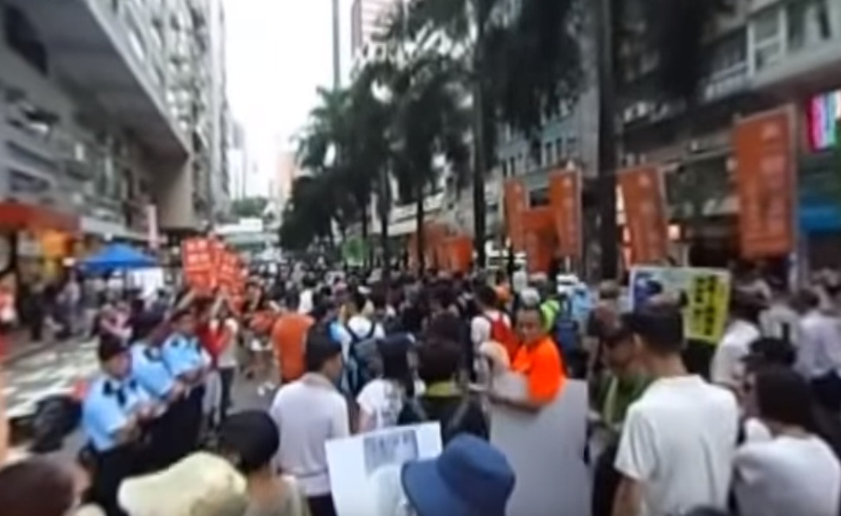
Teachers can visit our website to watch more learning journey videos and download flipped classroom worksheets:
https://www.mceducation.com.hk/vr/index.htm


Source B: An introduction to July 1 march
The July 1 march is a large march launched by social movement organisations such as the Civil Human Rights Front. It has been held on 1 July every year since Hong Kong’s Handover in 1997. It did not draw much public attention until 2003 because the government intended to implement the legislation of the controversial Article 23 of the Basic Law, which caused widespread concern that Hong Kong people’s freedom and human rights would be affected. In addition, government officials did not handle the SARS outbreak properly and this brought public outrage during that year. As a result, a large number of people took to the street to express their discontent with the government. Some organisations estimated more than 500 000 people joined the protest.

Source C: An excerpt from an article dated 23 July 2017
Every year the July 1 march calls for the Chief Executive to step down, but the reasons behind it are not the same. During the Tung Chee-hwa period, the public criticised the Chief Executive for his poor governance. People refused to support Tung because they hoped that a new leader could lead Hong Kong out of the economic downturn. During the Leung Chun-ying period, in addition to a demand for the Chief Executive’s quality of governance, the public even demanded more of his personal integrity and credibility. The root of the problem lay in the fact that there was no broadly representative electoral system. The reason for ‘Anti-Leung’, apart from his personal virtues, was that the public was dissatisfied with the political system in which the Chief Executive was elected. The purpose of the march was to call for improvements in people’s livelihood arising from political problems by reforming the system.
Five or six years after the Handover, due to economic recession, people usually marched to criticise government officials for failing to understand the needs of people from all social strata and to solve social conflicts. Later, the discontent of the public was directed against collusion between the government and the business sector and developer hegemony. In recent years, economic and livelihood issues have drawn less attention and so the focuses of the marches shifted to more controversial topics, such as fighting for universal suffrage and political reform. Some organisations have even put forward the slogan of safeguarding Hong Kong’s high degree of autonomy.

 | Questions

1 (a) Describe the July 1 march shown in the learning journey video in Source A.
‧ A lot of citizens march peacefully along the designated route.
‧ People of different political views promote their political ideas and shout slogans at the side. They also put up banners to strengthen their promotion.
‧ There are police patrols along the road to maintain order.

____________________________________________________________________
____________________________________________________________________
____________________________________________________________________
____________________________________________________________________

(b) According to Source B, in which year did the July 1 march begin to draw public attention? Why? Explain your answer.
‧ 2003
‧ The government intended to implement the legislation of the Article 23 of the Basic Law, which caused widespread concern that Hong Kong people’s freedom and human rights would be affected.
‧ Government officials did not handle the SARS outbreak properly in Hong Kong during that year, causing deaths of many health care workers and patients. This brought public outrage. As a result, more than 500 000 people joined the protest.

____________________________________________________________________
____________________________________________________________________
____________________________________________________________________
____________________________________________________________________
____________________________________________________________________
____________________________________________________________________
____________________________________________________________________
____________________________________________________________________
____________________________________________________________________

2 How did the July 1 march change over the years? With reference to Source C, explain your answer.
‧ Judging from the July 1 march over the years, the reasons for the public’s participation in the march have changed. As mentioned in Source C, during the Tung Chee-hwa period, the public criticised the Chief Executive for his poor governance, causing Hong Kong economy to go downwards and arousing widespread discontent in society. Therefore, the public participated in the march in the hope that a new leader could lead Hong Kong out of the economic downturn. Later, during the Leung Chun-ying period, the public not only thought that the Chief Executive was unable to govern, they even doubted his personal integrity and credibility. The root of the problem lay in the fact that there was no broadly representative electoral system. Therefore, the public participated in the march to call for improvements in people’s livelihood arising from political problems by reforming the system.
‧ Moreover, the public’s demands have also been changed. In the early years after the Handover, due to economic recession, the public demanded that government officials should understand the needs of people from all social strata and solve social conflicts. Later, the public believed that collusion between the government and the business sector and developer hegemony led to people’s poor life, and hence directed their complaints against them. In recent years, economic and livelihood issues have drawn less attention and so people shifted their focuses to more controversial topics, such as fighting for universal suffrage and political reform and safeguarding Hong Kong’s high degree of autonomy.
(Or other possible answers)

_______________________________________________________________________
_______________________________________________________________________
_______________________________________________________________________
_______________________________________________________________________
_______________________________________________________________________
_______________________________________________________________________
_______________________________________________________________________
_______________________________________________________________________
_______________________________________________________________________
_______________________________________________________________________
_______________________________________________________________________
_______________________________________________________________________
_______________________________________________________________________
_______________________________________________________________________
_______________________________________________________________________
_______________________________________________________________________
_______________________________________________________________________
_______________________________________________________________________
_______________________________________________________________________
_______________________________________________________________________

3 What drives Hong Kong people to participate in social and political affairs? With reference to the sources and your own knowledge, explain your answer.
‧ Firstly, Hong Kong people’s awareness of sense of identity has increased in recent years. They have a greater sense of belonging and responsibility towards the community, so they are more concerned about social and political affairs and willing to contribute to the well-being of the community.
‧ Besides, Hong Kong people’s civic awareness has also increased. The political culture of Hong Kong is inclined to pursue democracy, which makes the public become more active in various social and political affairs and generally adopt a peaceful and rational approach. As the public become more alert to politics, they begin to pay attention to the legitimacy and credibility of the government and even question the entire electoral system. As mentioned in Source C, in addition to a demand for the Chief Executive’s quality of governance, the public even demanded more of personal integrity and credibility. The root of the problem lay in the fact that there is no broadly representative electoral system, including the Chief Executive election and Legislative Council election.
‧ Moreover, mass media reports also help increase the incentive and responsibility of the public to participate in social and political affairs. As Hong Kong enjoys the freedom of the press, the media do not have to face the censorship of the government. Different opinions are tolerated and the media can gather public opinion. This enhances people’s political efficacy. In recent years, the rise of smartphones and social network websites allows people to quickly spread their own opinion on current affairs and daily life in words, pictures and videos.
(Or other possible answers)

_______________________________________________________________________
_______________________________________________________________________
_______________________________________________________________________
_______________________________________________________________________
_______________________________________________________________________
_______________________________________________________________________
_______________________________________________________________________
_______________________________________________________________________
_______________________________________________________________________
_______________________________________________________________________
_______________________________________________________________________
_______________________________________________________________________
_______________________________________________________________________
_______________________________________________________________________
_______________________________________________________________________
_______________________________________________________________________
_______________________________________________________________________
_______________________________________________________________________
_______________________________________________________________________
_______________________________________________________________________
_______________________________________________________________________

